How Does I2P Work?

Unlike many other anonymizing networks, I2P doesn't try to provide anonymity by hiding the originator of some communication and not the recipient, or the other way around. I2P is designed to allow peers using I2P to communicate with each other anonymously – both sender and recipient are unidentifiable to each other as well as to third parties.
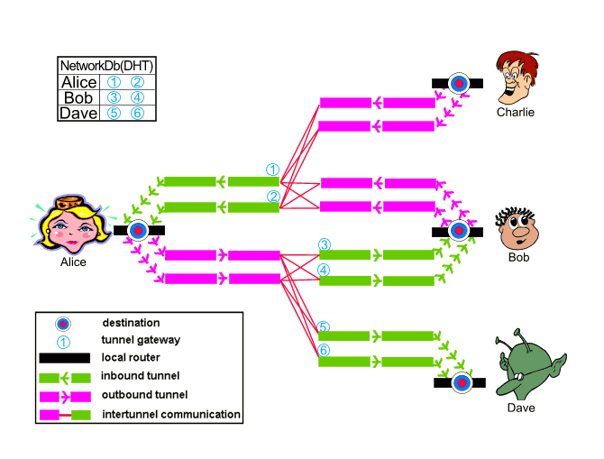
The network itself is message oriented – it is essentially a secure and anonymous IP layer, where messages are addressed to cryptographic keys (destinations) and can be significantly larger than IP packets. Some example uses of the network include “eepsites” (webservers hosting normal web applications within I2P), a BitTorrent client (I2PSnark / Robert), or a distributed data store. With the help of the I2PTunnel application, we are able to stream traditional TCP/IP applications over I2P, such as SSH, IRC, a squid proxy, and even streaming audio.

The network at a glance is made up of a set of nodes (“routers”) with a number of unidirectional inbound and outbound tunnels. Each router is identified by a cryptographic router identity, which is typically long lived. These routers communicate with each other through existing transport mechanisms (TCP, UDP, etc), passing various messages. Client applications have their own cryptographic identifier, which enables them to send and receive messages. These clients can connect to any router and authorize the temporary allocation of some tunnels that will be used for sending and receiving messages through the network. I2P has its own internal network database for distributing routing and contact information securely.

In the picture to the left, Alice, Bob, Charlie, and Dave are all running routers with a single destination on their local router. They each have a pair of 2-hop inbound tunnels per destinations (labeled 1, 2, 3, 4, 5, and 6), and a small subset of each of those router's outbound tunnel pool is shown with 2-hop outbound tunnels. For simplicity, Charlie's inbound tunnels and Dave's outbound tunnels are not shown, nor are the rest of each router's outbound tunnel pool (typically stocked with a few tunnels at a time). When Alice and Bob talk to each other, Alice sends a message out of one of her (pink) outbound tunnels targeting one of Bob's (green) inbound tunnels (tunnel 3 or 4). She knows to send to those tunnels on the correct router by querying the network database, which is constantly updated as new leases are authorized and old ones expire.

If Bob wants to reply to Alice, he simply goes through the same process – sending a message out one of his outbound tunnels targeting one of Alice's inbound tunnels (tunnel 1 or 2). To make things easier, most messages sent between Alice and Bob are garlic wrapped, bundling the sender's own current lease information so that the recipient can reply immediately without having to look in the network database for the current data.

To deal with a wide range of attacks, I2P is fully distributed with no centralized resources – and hence there are no directory servers keeping statistics regrading the performance and reliability of routers within the network. As such, each router must keep and maintain profiles of various routers and is responsible for selecting appropriate peers to meet the anonymity, performance, and reliability needs of the users. Individuals can increase their own anonymity by configuring their routers to use longer tunnels (more hops), albeit at a cost to network speed.

The network itself makes use of a significant number of cryptographic techniques and algorithms – a full laundry list includes 2048bit ElGamal encryption, 256bit AES in CBC mode with PKCS#5 padding, 1024bit DSA signatures, SHA256 hashes, 2048bit Diffie-Hellman negotiated connections with station to station authentication, and ElGamal / AES+SessionTag.

Content sent over I2P is encrypted through three layers: garlic encryption (used to verify the delivery of the message to the recipient), tunnel encryption (all messages passing through a tunnel are encrypted by the tunnel gateway to the tunnel endpoint), and inter-router transport layer encryption (e.g. the TCP transport uses AES256 with ephemeral keys).

End-to-end (I2CP) encryption (client application to server application) was disabled in I2P release 0.6; end-to-end (garlic) encryption (I2P client router to I2P server router) from Alice's router “a” to Bob's router “h” remains. Notice the difference use of terms! All data from a to h is end-to-end encrypted, but the I2CP connection between the I2P router and the applications is not end-to-end encrypted! A and h are the routers of Alice and Bob, while Alice and Bob in the following chart are the applications running on top of I2P.
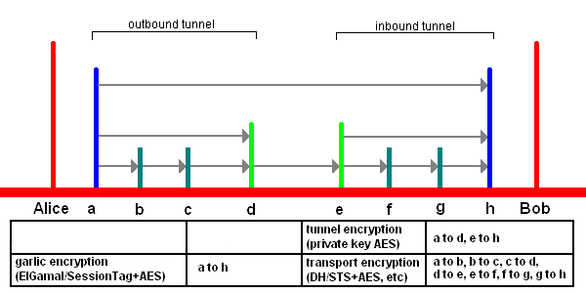
The two main mechanisms for allowing people who need strong anonymity to use the network are explicitly delayed garlic routed messages and more comprehensive tunnels to include support for pooling and mixing messages. These are currently planned for release 3.0, but garlic routed messages with no delays and FIFO tunnels are currently in place. Additionally, the 2.0 release will allow people to set up and operate behind restricted routes (perhaps with trusted peers), as well as the deployment of more flexible and anonymous transports.

